COURSE MATERIAL:
CO1: Linear Programming Problem by Simplex Method

TOPIC1:

Linear Programming Problem by Simplex Method in Mathematical Optimization
1. INTRODUCTION:

The graphical method of solving linear programming problem is an invaluable aid to understand its basic structure, the method is of limited application in industrial problems as the number of variables occurring there is substantially large.

Objective Function: A function to be maximized or minimized.
The objective of these contents is to provide some important concepts/methods to the reader like:
- Understand the meaning of the word ‘simplex’ and logic of using simplex method.
- Convert an LP problem into its standard form by adding slack, surplus and/or artificial variables.
- Set-up simplex tables and solve LP problems using the simplex algorithm.
- Interpret the optimal solution of LP problems.
- Recognize special cases such as degeneracy, multiple optimal solution, unbounded and infeasible solutions.

- Decision Variables: The variables that affect the outcome.
- Constraints: Conditions that must be satisfied.
Step by step procedure for solving the LPP by the Simplex method:
Let us explain the step-by-step procedure for solving the LPP by the Simplex method.
- Standard form.
- Introducing slack variables.
- Creating the tableau.
- Pivot variables.
- Creating a new tableau.
- Checking for optimality.
- Identify optimal values.

Mathematical Form (General)
Convert the LPP into standard form by adding slack variables:
We convert the given LPP into standard form by adding slack variables 𝑠1, 𝑠2, … , 𝑠𝑚.
Maximise Z = 𝐶₁𝑋₁ + 𝐶₂𝑋₂ + ⋯ + 𝐶_{𝑛}𝑋_{𝑛} + 0𝑠₁ + 0𝑠₂ + ⋯ + 0𝑠_{𝑚} Subject to the given constraints:
𝑎₁₁𝑥₁ + 𝑎₁₂𝑥₂ + ⋯ + 𝑎_{1𝑛𝑥𝑛} + 𝑠₁ = 𝑏₁
𝑎₂₁𝑥₁ + 𝑎₂₂𝑥₂ + ⋯ + 𝑎_{2𝑛𝑥𝑛} + 𝑠₂ = 𝑏₂
…………………………………………………………
………………………………………………………….
𝑎_{𝑚1}𝑥₁ + 𝑎_{𝑚2}𝑥₂ + ⋯ + 𝑎_{𝑚𝑛}𝑥_{𝑛} + 𝑠_{𝑚} = 𝑏_{𝑚}
and 𝑥𝑗 ≥ 0 𝑎𝑛𝑑 𝑠𝑖 ≥ 0 for all i =1, 2,……, m and j= 1,2, …, n

2. Construct the initial simplex table.
The initial simplex table is formed as follows:
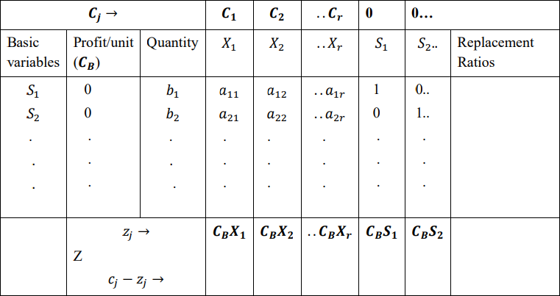

Step 5: Test for optimality
Calculate the values of 𝑐𝑗 − 𝑧𝑗, the nature of the solution could be any one of the following:
- If all 𝑐𝑗 − 𝑧𝑗 ≤ 0, the solution under test is optimal solution.
- If at least one value of 𝑐𝑗 – 𝑧𝑗 is positive and corresponding to the most positive 𝑐𝑗 − 𝑧𝑗, all the elements of the column 𝑋𝑗are negative or zero, the solution under test is an unbounded solution.
- Suppose at least one value of 𝑐𝑗 − 𝑧𝑗is positive. Suppose the most positive value is, say
𝑐₃ − 𝑧₃and at least one entry in the column of 𝑋₃ is positive. Then the solution under test is not optimal.

Step 6: Select incoming variable to enter the basis
If the solution is not optimal then we look for most positive entry and it could be any of (𝑐𝑗 −
𝑧𝑗). In this case, we proceed as follows to obtain the optimal solution:
- Let 𝑋𝑟 be the variable which corresponds to the most positive value of 𝑐𝑗 − 𝑧𝑗. This variable is called the incoming variable.
- The column to be entered is called the key or pivot column. Step 7: Test for feasibility (variable to leave the basis)

After finding the incoming variable, we determine the outgoing variable. For this we proceed as follow:
- We divide the value of the Quantity (Qty) column be the corresponding positive values in the column 𝑋𝑟. These ratios are called Replacement Ratios (RR). Note that we do not consider the negative values in the column of 𝑋𝑟 for calculating RR. Then we select the minimum RR. The basic variable corresponding to this value of the RR is called the outgoing variable. It is called outgoing variable because it is removed (goes out) from the next simplex table. The row selected in this manner is called key or pivot row.
- The element that lies at the intersection of the key row and key column is called the key element or leading element or pivot element.

Step 8: Finding the new solution
- We convert the key element to unity by dividing all entries in the row by the key element itself.
- In the next step, we would like that the values of all other elements in the column corresponding to key element are zero. For this we carry out suitable operations on each row using the row containing the key element.
New pivot row = Current pivot row ÷ Pivot element
All other rows, including z
New row = (Current row) – (Pivot column coefficient) * (New pivot row)
Step 9: Repeat the procedure
Go to step 4 and repeat the procedure until all entries in the 𝑐𝑗 − 𝑧𝑗 are either negative or zero i.e., we repeat the procedure until either an optimal solution is obtained or there is an indication of unbounded solution.

Conclusion:
We study simplex method which can be used for solving LPP involving more than two variables. Simplex method is an iterative method as it examines the extreme points in a systematic manner, repeating the same set of steps until an optimal solution is reached. We have introduced artificial variables which play an important role to solve an LPP involving greater-than or-equal to constraints and/or equality constraints.

